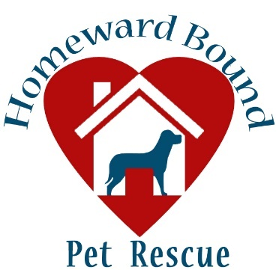
FOSTER & Volunteer APPLICATION
HOMEWARD BOUND PET RESCUE
PO Box 4335, Irmo, SC 29063 * (803) 454-9094
homewardboundrescue@hotmail.com

Date:
First & Last Name:
Street Address:
City: | State: |  | Zip: Code
Telephone: |  | Alternate Telephone:
Email Address:

VOLUNTEER:
I am interested in doing the following:
- Working at PetSmart Saturday Adoption Events (11:30 am – 4:00 pm) This entails unloading and loading dogs from cars, walking dogs (must be 18 years old) and breaking down crates
- Assisting with laundry items (mats and towels)
- Transporting animals (vet/HSPCA)
- Fundraising

What special talents do you have to share with Homeward Bound Pet Rescue? _________________________________

FOSTER:
Are you interested in □ Fostering Only □ Fostering to eventually adopt?
Type of foster: □ regular foster □ temporary or short-term foster? Fostering a heartworm positive dog for 4 weeks

Date you can begin fostering:
Age: Employer:

Size of dog (full grown) you are willing to foster: □ less than 20lbs □ 21 to 30lbs □ 31 to 50lbs □51 to 75lbs □ >75lbs
Gender of dog you are willing to foster: □ Male only □ Female only □ Either male or female
Age(s) of dog you are willing to foster: □ nursing litter □ 8 wks to 6 mos □ 6 mos to 1yr □ 1yr to 5yr □ 5yr+ □ Any age
I would foster a dog who is: □ blind □deaf □ pregnant □ amputee □ ongoing medical needs □ hypoallergenic only

I live in a: □ house/townhouse I own □ house/townhouse I rent
□ apartment/condo I own □ apartment/condo I rent

Name, Phone Number & Email Address of Landlord:

Names and ages of all individuals living in the home:
Name, type, gender, spay/neuter status of all pets you have or have owned in the last 5 years. If you no longer have them, note reason:

Vet Reference:
Please list the name and phone number of your current vet. ________________________ Phone_________________

Please list the name/phone of previous vets that you have used with your current pets.
_________________________ Phone________________

What name (yours/spouse?) will the vet account be listed under? __________________________________________

What flea/tick preventative do you use?
What heartworm preventative do you use?

Do you have a fenced yard? □ yes □ no If yes, type fence height

How many hours per day will your foster dog be alone?

Where will your foster dog stay while you are away from home?

Personal Reference (please choose someone who doesn’t live with you) :
Name______________________________ Relationship________________________________
Telephone Number______________________________________

Additional information that will assist us in finding a suitable foster dog for you:

Waiver of Liability
Foster families accept liability for personal injury or damages caused by the foster dog. It is understood that dogs can be unpredictable and caution must be taken in caring for foster animals. Your foster dog will remain the property of Homeward Bound Pet Rescue while in your care and all decisions regarding the welfare, medical treatment, & future placement will be the at the sole discretion of Homeward Bound Pet Rescue.

By submitting this application, you agree to abide by the policies, procedures, & decisions of Homeward Bound Pet Rescue.

Signature: Date:

